**Dynamic AI based Email Voice Assistant for Web Services**

The project aims to develop a personal-assistant for Window-based systems. Jarvis draws its inspiration from virtual assistants like Cortana for Windows, and Siri for iOS. It has been designed to provide a user-friendly interface for carrying out a variety of tasks by employing certain well-defined commands. Users can interact with the assistant either through voice commands or using keyboard input. As a personal assistant, Jarvis assists the end-user with day-to-day activities like general human conversation, searching queries in google, searching for videos, retrieving images, tells jokes, temperature, make a note, about corona cases , can open Facebook, Instagram, calculator, command prompt, date and time. The user statements/commands are analyzed with the help of machine learning to give an optimal solution.

In this Project Jarvis is Digital Life Assistant which uses mainly human communication means such Twitter, instant message and voice to create two way connections between human and his apartment, controlling lights and appliances, assist in cooking, notify him of breaking news, Facebook’s Notifications and many more. In our project we mainly use voice as communication means so the Jarvis is basically the Speech recognition application. The concept of speech technology really encompasses two technologies: Synthesizer and recognizer. A speech synthesizer takes as input and produces an audio stream as output. A speech recognizer on the other hand does opposite. It takes an audio stream as input and thus turns it into text transcription. The voice is a signal of infinite information. A direct analysisand synthesizing the complex voice signal is due to too much information contained in the signal

**Problem Identification & Objectives**

A voice assistant or intelligent personal assistant is a software agent that can perform tasks or services for an individual based on verbal commands i.e. by interpreting human speech and respond via synthesized voices.

Users can ask their assistants’ questions, control home automation devices, and media playback via voice, and manage other basic tasks such as email, to-do lists, open or close any application etc with verbal commands.

Who doesn't want to have the luxury to own an assistant who always listens for your call, anticipates your every need, and takes action when necessary? That luxury is now available thanks to artificial intelligence-based voice assistants.

Voice assistants come in somewhat small packages and can perform a variety of actions after hearing your command. They can answer questions, play music, place online orders and do all kinds of AI-based stuff.

Voice assistants are not to be confused with virtual assistants, which are people who work remotely and can, therefore, handle all kinds of tasks. Rather, voice assistants are technology based. As voice assistants become more robust, their utility in both the personal and business realms will grow as well.

## EXISTING SYSTEM:

Existing methods user manual email processing or web-based applications with manual text processing techniques using NLTK and natural language processing.

### 4.1.1 DISADVANTAGES OF EXISTING SYSTEM:

* + - Send Gmail messages
    - Dynamic News reporting at any time
    - Open any website with just a voice command
    - Plays music
    - Tells time
    - Wikipedia powered AI
    - Dictionary with intelligent Sensing i.e auto checking if spell mistake
    - Weather report such as temping
    - Speed, Humidity, Weather description
* Latitude and longitude

## 4.2 PROPOSED SYSTEM:

* A voice assistant is a digital assistant that uses voice recognition, natural language processing and speech synthesis to provide aid to users through desktop and voice recognition. Voice assistants are built on artificial intelligence (AI), machine learning and voice recognition technology. As the end user interacts with the digital assistant, the AI programming uses sophisticated algorithms to learn from data input and better itself at predicting the user's needs. Some assistants are built with more advanced cognitive computing technologies which will allow a digital assistant to understand and carry out multi-step requests with numerous interactions and perform more tasks Digital assistants can be contrasted with another application of consumer-facing AI called smart advisors. Smart advisor programs are knowledge-oriented, while digital assistants are taskoriented, although some perform both roles. Popular voice assistants currently include Apple's Siri, Amazon's Alexa, Google Now, Google Assistant and Microsoft's Cortana.
* This Software aims at developing a personal assistant for Windows-based systems. The main purpose of the software is to perform the tasks of the user at certain commands, provided in either of the ways, speech or text. It will ease most of the work of the user as a complete task can be done on a single command. Jarvis draws its inspiration from Virtual assistants .Users can interact with the assistant either through voice commands or keyboard input. Artificial intelligence (AI) is the ability of a computer program or a machine to think and learn. They work on their own without being encoded with commands. These software components cover machine learning, image recognition, natural language processing, data mininig and more.

### 4.2.1 ADVANTAGES OF PROPOSED SYSTEM:

* + Voice commands are used to processing commands
  + Only voice-based system is used manual work is reduced.
  + User can access information on travel also.

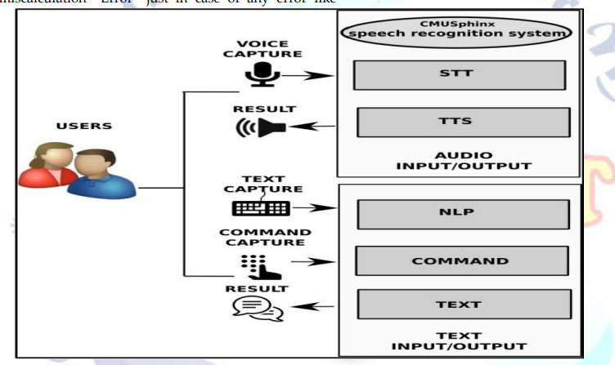

## SYSTEM REQUIREMENTS

### 6.1.1 HARDWARE REQUIREMENTS:

* System : Intel(R) Core(TM) i3-7020U CPU @ 2.30GHz
* Hard Disk : 1 TB.
* Input Devices : Keyboard, Mouse
* Ram : 4 GB.

### 6.1.2 SOFTWARE REQUIREMENTS:

* Operating system : Windows XP/7/10.
* Coding Language : Python
* Tool : Anaconda
* Interface : OPENCV